Dr. Pinhas CHEM2040
SI Session 19 April 2018– Final Review
Quote of the Week !! “What you get by achieving your goals is not as important as what you become by achieving your goals.”
- Henry David Thoreau
1. Show all reasonable resonance structures for the following molecules
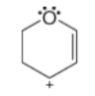
a.)

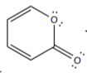
b.)

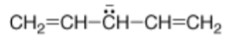
c.)

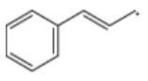
d.)

2. Propose a synthesis, starting with only ethanol or methanol as a carbon source, to make:
trans-2-butene

React with Cl₂ and H₂O, showing the full mechanism. In the product, circle any chiral centers. Label each S or R. If there are multiple products, show work to explain the relationship between them.

3. Fill in the missing product
a..)
H₂O

b.)

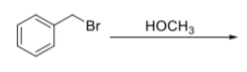
c.)

d.)
hv
NBS

4. Drawing the chair conformation, explain the reaction between the following molecules:
NaOCH₂CH₃

5. What is the structure of Compound O - C₁₀H₁₂O?
