Stephen George
Professor Gary Vaughn
English 2089
1 December 2017
Oui, Oui, Baguette: How I Fell for French
Sometimes Sunday mornings prove to be tranquil, as the unhurried family joyfully relishes in the promise of a restful day, sharing in laughter and company on the familiar van ride to their 10 o’clock church service. Sometimes Sunday mornings are slow and lazy and quiet, but nonetheless, the family gathers in silence to pile once again into that van for the service. Sometimes Sunday mornings are easy and simple, and that ride sneaks by like a breath, routine and unnoticed. Other Sunday mornings are not of the same caliber.
In this same van, on one of those different Sunday mornings, my older sister Nicole smirks at me in mischief and nods, signaling me to join her as we outright scream the French ditty, “Donnez-moi un bonbon, parce que je suis bon!” We are delighted in ourselves, as we have broken any pre-existing peace of the van ride, causing our mother to nearly spill her thermos of coffee all over her floral skirt. Somehow, our dad still chuckles at our obsession with this simple children’s song we have adopted as our sibling anthem for the last three weeks. Nicole and I explode into laughter as we continue to haunt our parents and little sister with the annoying French tune that feels like our own secret and separate language, bonding us apart from the rest of our family. We also delight in the fact that the tune is a childish demand for candy, which is highly relatable.
That nursery rhyme Nicole taught me was my first proper exposure to the French language, outside of learning to count to five and jokingly sneering through nasal laughter the classic, “Oui, oui, baguette,” as everyone does to mock the French, of course. Nicole began taking French as her foreign language requirement during her eighth-grade year, and I felt empowered when she decided to pass down to me some of the lessons from class which truly struck a chord with her. For there is some level of unspoken honor passed down when an older sibling dubs the younger sibling worthy of being on the inside of some joke or knowledge. Who could have predicted this shared desire to taunt our family during car rides would launch a lifelong literacy pursuit?
Though she could not have anticipated it when she first began to teach me French, Nicole certainly holds the title as my first literacy sponsor. When I reached eighth grade and needed to choose my own foreign language to pursue, I naturally chose the laziest option possible, following in Nicole’s footsteps with the exclusive goal of having her help me with homework to minimize my own efforts. However, when classes began, I marveled at the fact that Nicole had actually taught me worthwhile material beforehand, and I felt some level of authority when I entered the first quarter of class with bits and pieces of knowledge in French which my classmates had never before encountered. Enthralled, I realized that my initial choice to take French, founded in laziness, slowly evolved into a beast of genuine intrigue and eagerness for increased fluency.
Literacy, meaning one’s fluency in a given skill or practice, can be seamlessly applied to the process of language acquisition, as the ultimate goal is, of course, literal fluency in the language. Literacy in a second language entails essentially the same tasks as traditional literacy: practices in reading, writing, and speaking the language of concern, but an additional aspect of second language literacy is the investment needed to study and comprehend the culture surrounding that language. The concept of spending the time to become fluent in a new culture and a new people drew me to pursue true literacy in the French language for years to come.
I am not certain there is anything particularly special about the French language itself which made me want to continue the study of a second language, but rather my motivation stemmed from the concept that so much more knowledge and experience and richness of humanity exists in our world which I had not experienced as a white teenage male from the suburbs of Columbus, Ohio. I craved interaction with the unknown and thirsted for fresh perspective from people who lived and thought differently than I.
As my literacy increased, I began to see my thought formation adjust to two languages, each of which carries its own history and cultural weight. Reading full texts in French introduced me to a strange new world of thought, as the language is fundamentally constructed differently than English. When I became used to this new construction, my own thoughts started to blur in their structure, which was a nearly indescribable transition. In his “What Writing Is,” author Stephen King describes the exchange that happens cognitively while reading a text, saying, “We’re having a meeting of the minds” (106), explaining what to me was the precise thrill that comes from reading first-hand accounts of life in French. There is a nearly-visible tilt in mental perspective as a second language seeps its own cultural baggage into everything you are.
All the same, there existed for years a dividing wall between myself and true fluency in this particular literacy because I had only had King’s “telepathic” mind-meetings with the French, which came from reading educational texts, instead of having genuine human interaction; I was growing exhausted while settling for what seemed like a child’s literacy level as I learned from a distance. I entered college with intention of pursuing education in French language, yet I had never surpassed only mind-meetings with a French person. I was thirsty to finally visit France and to have my own first-hand experience in mutually seeking a better understanding of what it was to be human with some French stranger in their own language. Even though the thought of actually doing this made my stomach do backflips, I could still hear the depths of my being call out for this sort of genuine human connection.
So I go.
All of a sudden I am in college, and all of a sudden the University Honors Program announces that Professor Cathy Lorenz will be leading an honors seminar entitled “Contemporary Paris” which of course entails a spring break excursion to the City of Lights. I firmly believe that I must have been the very first person to sign up for that class, and soon enough, I am on a plane to Paris.
Though I would love to explain in full detail about how Paris is so clearly the best city on the planet, how my jaw dragged all the way down the Champs-Elysées the first time I walked down the iconic avenue, how heartbreakingly romantic is the city center where the Seine river is traversed by ornate bridges on which walkers pause to enjoy the surrounding bustle, and how the grand Eiffel Tower just peeps out quietly behind the uniform rooftops of the city, like a playful kitten demanding now and again your attention, one particular experience in the city has become especially imprinted in my memory.
Because the course which brought us to Paris was an honors seminar, few of my classmates had any experience at all in the French language. So, every evening when we split up to hunt for the best food we could find, I was charged with the role of translator.
There is a street in the Latin Quarter of Paris which transports you into a terrifying world. Both sides of the lowly lit cobblestone street host only restaurants, for what seems like an endless tunnel of chaos and noise. If only we understood the gravity of what we were about to enter when we dared to venture forward into the pathway; almost immediately, restaurant owners, all of whom are all middle-aged French men with strange suit jackets covering their three-fourths buttoned white, collared shirts, begin to genuinely battle for our business. A man on the right, owner of the Mediterranean restaurant, comes to shake hands with the terrified girls at the front of our group, pleading that we “S’il vous plaît, examinez-vous le menu!” (please look at the menu) while the Italian restaurant manager comes forward from directly across the street and outright spits in French slang that “Les plats méditerranéens sont à chier” (the Mediterranean food is shit). Of course, none of the girls I’m with have the slightest concept of what these men are saying, as their now-sour faces clearly demonstrate, and they begin to actually flee the scene in reaction to the approaches of these forty-year-old scrubs.
Eventually, the manager of a different Italian eatery up the street will not leave the girls ahead alone, and as though one of them ratted me out as someone who dabbles in the French language, I see the man suddenly turn to me and begin to bombard me with rapid French.
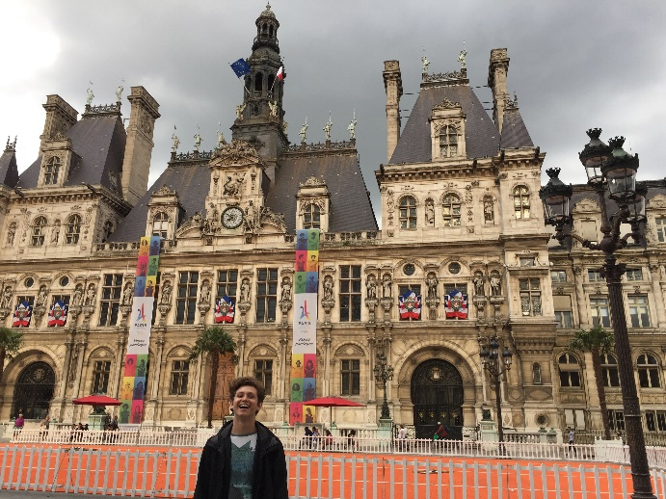
But in this overwhelming moment, I see my literacy unfold and become justified before my own eyes. I can understand the panicked French of this man who only wants our euros, I am able to realize that his menu actually entailed some trendy and bold plates to have on an Italian menu, and I am able to outright lie to the man, saying that we are extremely excited to come back to his establishment in five minutes once we find the rest of our group to announce to them how great of a restaurant we stumbled upon for dinner. Relieved, the man releases his forceful hand from my shoulder and hurries to write down how many people are in our party as we sprint away, trying not to stumble again on the uneven cobblestone. I believe this encounter is cemented into my memory because of the abounding joy I had when I realized I was at last a fully capable francophone; my French language literacy had grown significantly indeed, even to the extent that I could lie and be believed.

This summer 2017, I returned to Paris for the first time Photographed by my friend Catrina Rateb.

After realizing the success of my literacy and experiencing the empowerment of being understood at a human level, I spent a considerable amount of time during the rest of the trip teaching and helping my classmates as they stumbled blissfully, like toddlers who cannot hold their own weight, through the basics of the language. What a joy it was when the end of our week found us exclaiming the subway announcements alongside the PA system at every stop, for my classmates were clinging to a new skill, one which is packed with hundreds of years of memories and history, and I was a witness to their beginning to develop the literacy of French language too.
I believe, therefore, that there is some pull or perhaps aura about literacy in a particular subject or skill which creates in a person the desire to preserve and spread that literacy. Just as mothers pass on recipes to their children, craftsmen teach their skills to apprentices, and Nicole sang to me her ditty from French class, I have been a witness to the fact that literacy creates a need and desire within an individual to connect and share with people who identify with the same fluency, and this naturally stems into teaching a literacy to those who might be willing to learn. Sherman Alexie explains in his article, “The Joy of Reading and Writing: Superman and Me,” how he desperately longs to be an example for Native American children, saying, “I throw my weight against their locked doors. The door holds” (364). I identify with Alexie’s desire to change the status quo of those whom I love. I want others to see the value in learning language, for it is a true doorway into a world of grander perspective and opportunity to connect with vaster varieties of people. Human beings are not all alike, yet somehow simultaneously, we are, and I believe it is utterly necessary to understand both of these truths firsthand. French has provided me with opportunities to learn more about the world and about the human condition in a much broader spectrum than I think most of my peers have experienced, and I long too for more youth to see this world in the light of second language literacy.
Literacy inspires the passing down of fluency, based in passion, and I want to continue this historic flow, just as my sister did. I hope to teach my future children to understand French and to seek even more languages to pursue fluency in as well. Perhaps their literacy journeys will begin with juvenile ditties such as “Donnez-moi un bonbon,” or perhaps the literacies they pursue will look increasingly different than those which have greatly impacted me. Regardless, I too hope someday to be able to chuckle quietly to myself as I see in my kids behind me the same seeking after literacy exchange as I experienced in those car rides, on those Sunday mornings, with my sister Nicole and pure, reckless joy of life: joie de vivre.

Works Cited
Alexie, Sherman. “The Joy of Reading and Writing: Superman and Me.” Writing about Writing: A College Reader. 1st ed. Ed. Elizabeth Wardle and Doug Downs. Boston: Bedford/St. Martin’s, 2011. 363-365. Print.
King, Stephen. “What Writing Is.” On Writing. New York: Scribner, 2000. 103-107. PDF.

